TLS/SSL Analysis By Analyzing a PCAP Trace
Objective
- To analyze the TLS/SSL protocol using a PCAP Trace
Description
- Students may work individually or form a team of up to four members to complete the project. While teamwork is allowed, students are encouraged to complete the project on their own.
- All students must submit their own answers to this project.
- Both undergraduate and graduate students are required to answer all questions.
Submission
- All students must complete Project 4, which is listed under the Quiz category;
- All students must also submit an analysis report explaining how the results were derived from the given trace. Students working in the same team may submit an identical report; however, each student must upload the report individually.
- For your answer to each question in the analysis report, please include the screenshot of the relevant code snippet and your analysis.

Your Name: Josiah Schmitz
UID: U01049737
Team Members Including Yourself: Josiah Schmitz

Q1: Which of the following Cipher Suite(s) is(are) supported by the client?
Screenshot:
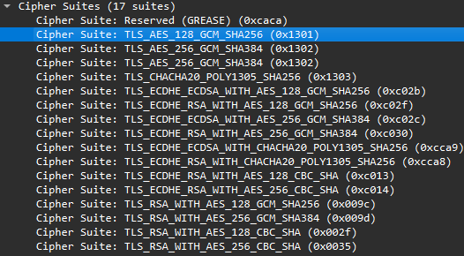
Answer: By analyzing the Client Hello packet, we can see all of the 17 supported cipher suites listed under TLS details. All four of the cipher suites given as options are listed here (as seen above). Therefore, all four options are correct.

Q2: Which cipher suite is used by this TLS session?
Screenshot: 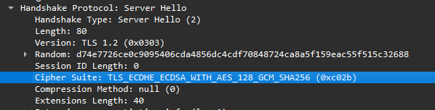
Answer: By analyzing the TLS details of the Server Hello packet, we can see that it lists what cipher suite it is using for communication. As seen above, the cipher suite is TLS_ECDHE_ECDSA_WITH_AES_128_GCM_SHA256.

Q3: What is the public key generated by the server for the key exchange protocol (i.e., EC Diffe-Hellman)?
Screenshot: 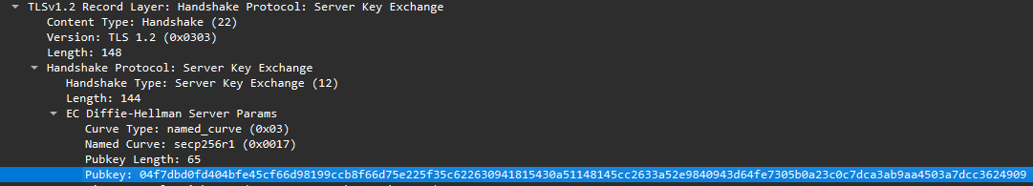
Answer: By analyzing the packet containing the Server Key Exchange, we can find the EC Diffie-Hellman Server Params generated for this communication. One of those params is the public key, which is 04f7dbd0… etc.

Q4: What is the public key generated by the client for the key exchange protocol (i.e., EC Diffe-Hellman)?
Screenshot:
Answer: The same process as the last question can be used to find the client’s public key, this time by analyzing the Client Key Exchange packet. Here, the public key is shown to be 04c42800… etc.

Q5: How many certificates are returned from the server to the client?
Screenshot:
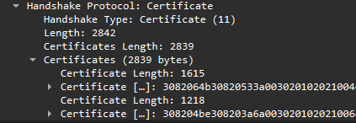
Answer: By looking at the Certificate packet (the same one as the Server Key Exchange), we can find all the certificates listed under the Handshake Protocol. Expanding the Certificates tab shows that there are only 2 total certificates in this communication.

Q6: Which one best describes the name of the root certificate authority?
Screenshot: 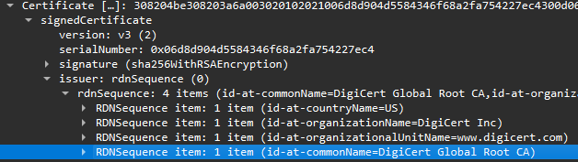
Answer: We can continue to analyze the Certificate packet to find the CA’s names. Under the Issuer tab of the last certificate listed (the root certificate), the “id-at-commonName” is labeled as “DigiCert Global Root CA.”

Q7: Which one best describes the name of the intermediate certificate authority?
Screenshot:
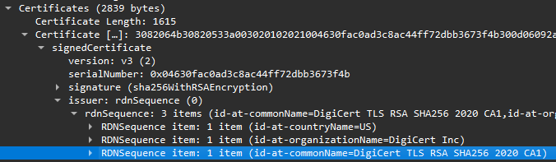
Answer: We can then just apply the same process to find the name of the intermediate CA. The first certificate listed has its “id-at-commonName” field set to “DigiCert TLS RSA SHA256 2020 CA1.”

Q8: which of the following domain names is eligible to use the certificate returned from the server to the client (i.e., with the serial number of 0x04630fac0ad3c8ac44ff72dbb3673f4b)?
Screenshot: 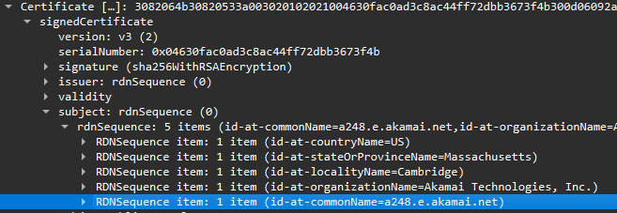
Answer: Under the certificate with that serial number (the intermediate certificate), we can see what domain names are listed under the Subject field for the certificate. Here, “a248.e.akamai.net” is listed, with that being the only option for a domain name.

